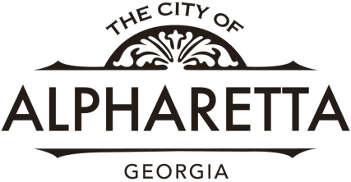
Employee Referral Form

Return Completed Referral Form to Kathy Bott in the Human Resources Department
The City of Alpharetta Employee Referral Program is designed to enhance employee recruitment by encouraging current employees to refer high-quality applicants for City jobs. Referrals often succeed because workers who recommend their friends and contacts want the referral to reflect well on them and they want to work with qualified colleagues.
If you have referred an employee for a position with the City of Alpharetta, please complete this form and submit it to Kathy Bott in the Human Resources Department.
Referring Employee Information
Name:
Department:
Date:

Applicant Information
Name:
Position Desired*: Hired:

A current employee who successfully recruits an applicant will receive an award of $1000 in his/her paycheck following the applicant’s successful completion of his/her ninety (90) days from the hire date. An additional $1000 award will be received in the paycheck of the referring employee following the applicant’s successful completion of one (1) year of employment from the hire date.

A referral form must be submitted to the Human Resources Department before the vacancy closes in order for the current employee to be eligible for the referral award.

*To qualify for a referral award, both the hired employee and the referring employee must be regular full- or part-time employees.

For Human Resources Use Only

90-Day Award Due: | 90-Day Award Check Requested:
1 Year Award Due: | 1 Year Award Check Requested:
Comments:_________________________________________________________________________________________________________________________________

