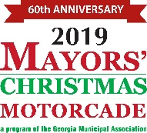

PUBLIC SERVICE ANNOUNCEMENT
(30 seconds)

Hello, my name is, __________________________________ , and I am

with the City of .

For 60 years, cities throughout the state of Georgia have brought holiday joy to the thousands of patients living in the state’s regional behavioral health facilities. Through the Mayors’ Christmas Motorcade you can provide gifts to people who otherwise might be forgotten during the holidays.

If your school, church, business or civic group would like to participate in this outstanding holiday community project, please contact
at .

Let’s not forget those less fortunate during this holiday season.

