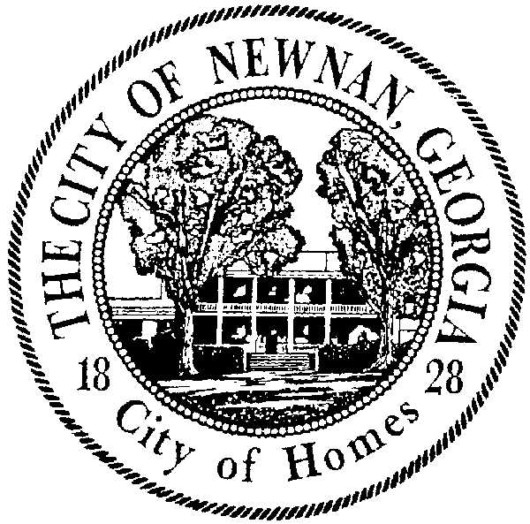
CITY OF NEWNAN, GEORGIA
NEWNAN YOUTH ACTIVITIES COMMISSION
and NEWNAN YOUTH COUNCIL

January 8, 2019

We are asking for the cooperation and support of the High School Principal and Parents to excuse _______________________________________________ from school on Wednesday February 6, 2019 to attend a Newnan Youth Council field trip to the State Capitol to interact with state legislators and observe a state legislative session.

The City of Newnan Youth Activities Commission is asking that your child be allowed to attend this function and represent their high school as a part of the City of Newnan Youth Council.

We encourage you to request oral and/or written reports of their governmental experience.

Thanks for your support,

City of Newnan Youth Activities Commission

*************************************************************************************
*************************************************************************************

I hereby give my permission for my son/daughter to attend the above referenced event.

______________________________________ __________________
Signature (Parent or Guardian) Date

I hereby give my permission for the student to attend the above referenced event.

______________________________________ __________________
Signature (High School Principal) Date

