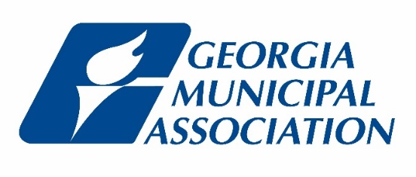
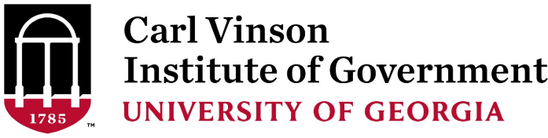

Effective Practices for Municipal Operations 101
2022 GMA Annual Convention
Saturday, June 25, 2022
8:15AM - 11:15AM

Welcome and Introductions Artiffany Stanley, Georgia Municipal Association

Process Principles – “How We Do Things”

-Acting Strategically Stan Brown, Georgia Municipal Association
-Operational Effectiveness
-Regulatory Compliance

-Fiscal Responsibility Judy McCorkle, City of Sandersville
-Asset Management

Stretch Break

People Principles – “How We Treat People”

-Employee Development Artiffany Stanley, Georgia Municipal Association
-Customer Service
-Communication

Q&A Panelists: Artiffany Stanley, Judy McCorkle, & Stan Brown

Adjourn

