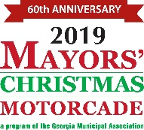

Sample Letter

To the Editor:

In the state of Georgia, there are hundreds of citizens living in facilities that serve clients with developmental disabilities and behavioral health needs. Many of these clients have little, if any, contact with or support from friends or family. During the holiday season, cities from all over Georgia look to ensure those clients receive gifts.

In 1959, the Georgia Municipal Association and then-Governor Ernest Vandiver created the Mayors’ Christmas Motorcade to help these hospital clients celebrate Christmas by providing each with a present. The staff at the facilities tell us that without the Mayors’ Christmas Motorcade, many patients would go without any gift or recognition during the holidays.
And the giving does not end at the holidays. Any items not used at Christmas are used throughout the year to celebrate birthdays and other special days.

Our city has started its gift collection campaign, and we are asking for your help. The facility clients are part of our community, and we would like to encourage all of you to remember them this holiday season. If your school, church, business or civic group would like to participate in an outstanding holiday community project, please contact
at _________________for further information on how you can get involved.

Let’s not forget those less fortunate during the holiday season.

